KESLConfig App

# Introduction

The KESLConfig App is an IOS version of the app that can be directly connected to the KESL tag to refresh the data. The app has built-in tag images for each model of ESL. You can also import your own created images with the iTunes tool.

KESLConfig App download link:

<https://testflight.apple.com/join/IXSxwbHw>

You can ask the sales for the app source code.

# Software/hardware Architecture

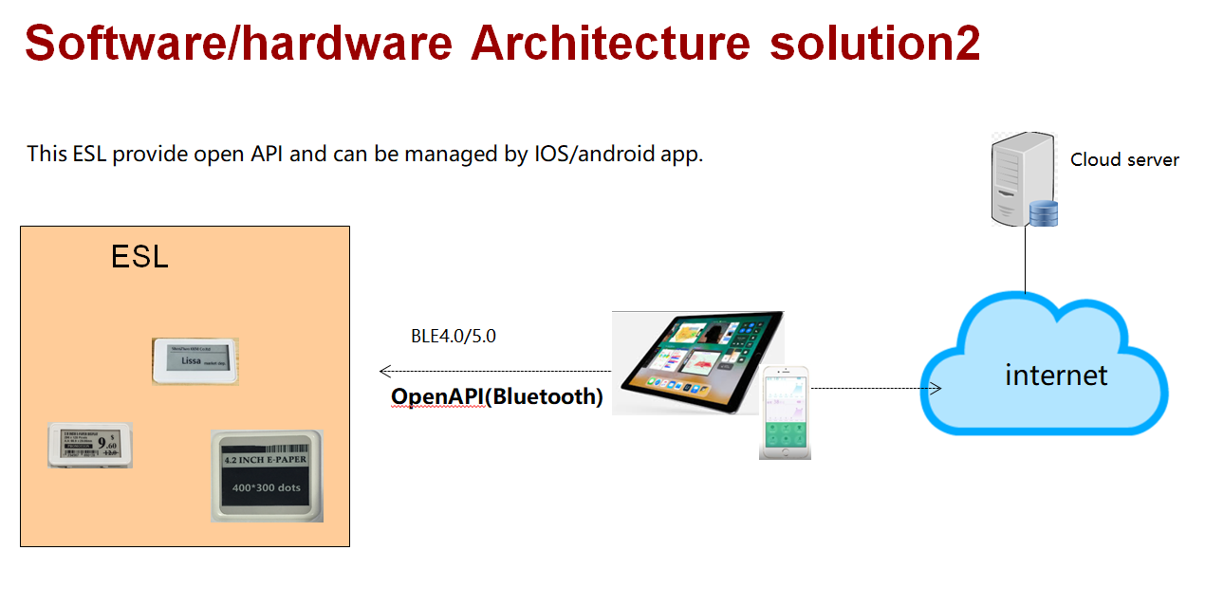

# Create ESL picture

1, making BMP picture files, making method reference《ESL Picture production.docx》

2. Put the prepared BMP image and Bmp2EslJson.exe in the same directory.

3. Execute the following command:

* Method 1: Double-click the Bmp2EslJson.exe program to convert the picture according to the prompts.

Method 2: execute command Bmp2EslJson.exe -f goods2.bmp -t e29 -p 00000000 -m 0C23CAF98100 -id 1478 -s 123 -z y

Note 1: The mac address can be input any value, must be 12 Byte.

Note 2: Currently the app only supports compressed file format, so the -z parameter should choose y.

4. After the command is successfully executed, a JSON file will be generated. If the execution fails, a prompt error will be generated.

PARAMATERS：

-f：file name

-t：e21，e211，e29，e291，e42

-p：password

-m：mac address

-id：picture ID

-s：json message ID

-z：compress mode，y means compress，n means no compress

# Import the created image into the app

1. Connect your iPhone to your computer and click on the phone icon to go to the database.

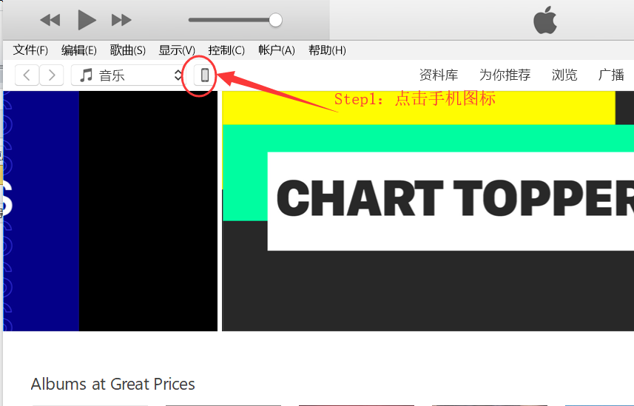

2. Add the created file to your app and click Sync.

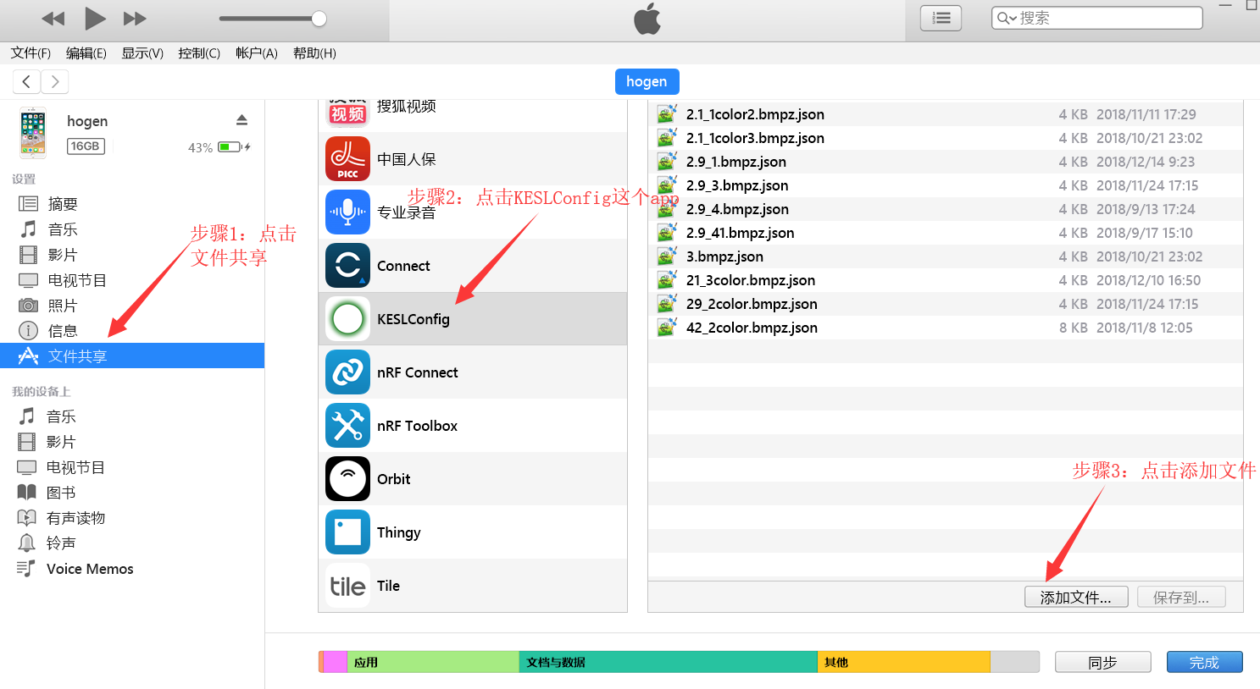

3, run the app, you will find these files are already in the app, you can choose to click to send. Please note that the file needs to match the corresponding label screen size, otherwise it will prompt that the file format and device do not match.

a) The App will scan all the KESL device, the strongest signal is at the top.

So please take the KESL label which you need to refresh close to your phone, making sure the first one is.

b) Click to enter, you can directly send the default file. You can also click to modify the file.

c) Click on the modified file, you will find that the file you just added through itune is already in it, you can choose it.

